## UCF cARdiac-2.0 - User Guide

# Using the HoloLens 2

Official Microsoft documentation on HoloLens 2 device <https://learn.microsoft.com/en-us/hololens/hololens2-basic-usage>

Controls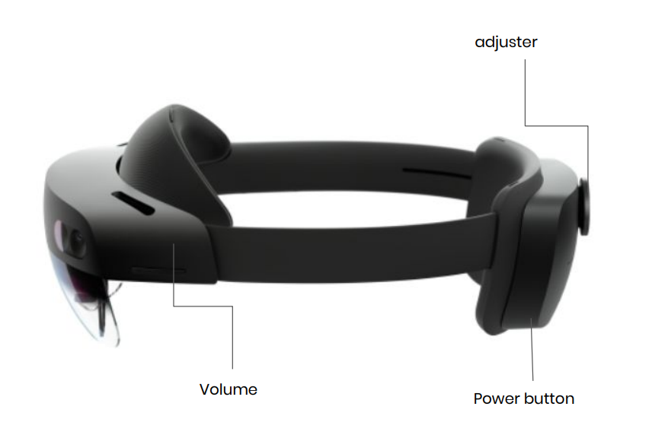

### When the screen is close up

* To select something: Tap with your finger in the air and release.
* To scroll: Put your finger on the holographic screen and swipe across the content like you would with a normal touchscreen.
* To grab the menu: Pinch your thumb and index finger together on the hologram and hold and move the hologram.
* Open context menu: Tap with your finger on the hologram in the air and hold.

### When the screen is far away

Air ray: The ray that appears when you point at something with your index finger in the holographic world.

Air tap: Select with air ray and pinch your thumb and index finger together to select.

* To scroll: Pinch your index and thumb together and drag up and down to scroll.
* To grab from far: Point your air ray on the content and make a grab gesture to pull the content to or away from you.
* Open context menu: Air tap and hold with your air ray to open the context menu. (copy, paste, delete, etc)

### Pressing buttons

Make sure you push deep into the buttons (holographic keyboard, etc) with your index fingers when typing, otherwise, it won’t react.

For the slider element, it works best if you put your finger slightly behind the slider itself and move the finger more aggressively.

### One-hand home button trick

It is possible to open your home menu with one hand.

1. Stare at the home button on the wrist of your hand.

2. Pinch your index finger and thumb together to open the home menu while staring at your wrist.

Resizing objects/holograms

1. Grab the corners of the hologram, pinch, and bring your hands closer to make the hologram smaller,

### Important to note

Expanding the heart model or running too many animations at once (using blood and electrical animations and changing the size at the same time) could slow down the application

## Launching the App

* Put on the HoloLens 2, adjust the size with the roller on the back
* Press behind the HoloLens 2 on the power button to turn on the device.
* Enter the password for the device
* Main menu will appear. Verify that the Internet connection is UCF_WPA2
* If the screen is not clearly visible, ensure that the set fits well on your head and that the visor is pushed down all the way. If the issue persists, Calibrate your eyes. Go to Settings > System > Calibration > Eye Calibration > Run eye calibration and follow the instructions on the screen.

Note: The eye calibration will appear automatically if the device detects that it is needed.

* Click on the cARdiac app icon to launch cARdiac application.

# Using the Cardiac 2.0 app

## Login

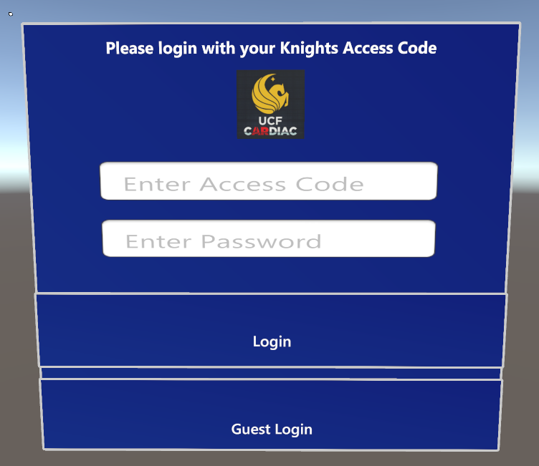

1. Students should log in with their Acess Code and a password provided by the faculty. Simply tap on the button with the index finger and type the access code on the keyboard that appears using the index finger on either hand. Then, press the Login button. Depending on the Internet connection, Login might take a few moments.
2. In case of no stable Internet connection, users can log in as a guest. In this case, the progress is not stored. Simply press the Guest Login Button

## Welcome scene

On the welcome scene select Tutorial to enter the Tutorial or press Launch app to skip the tutorial and access the app directly. The Tutorial will be launched automatically once the Countdown is finished.

## Tutorial

Follow the prompts on the screen to familiarize yourself with the functionality of the app.

## Class Selection

The screen would ask whether you want to view the content for M1 or M2 students. First-year students should select M1, second year - M2.

## M1 Students

### Main Scene

#### Scene Menu

Displays the Information about the heart functionality on the Information panel. Tap on each to See additional information in Field C. Tap on Flashcards to enter the Flashcards Scene

#### Heart model

Displays Sinus rhythm animation and labeled heart anatomy

#### Information Panel

Displays the heart functionality information and additional information on the anatomy.

#### ECG Video

Displays Sinus rhythm ECG video for various heart rhythms

#### Heartbeat rhythms

Change the speed of the heart animation by pressing the buttons: Bradycardia, Normal, or Tachycardia respectively.

#### Heart Controls

Anatomy - allows the user to enable/disable anatomy labels on the heart model

Reset - Reset the position of the heart to the default position in case it gets out of sight

Tutorial - Launches the tutorial again, in case any help is needed

#### Home Button

Returns the user to the M1/M2 selection and the logout

## M2 Students

### Main Scene

#### Heart Functionality Buttons

1. Home - Goes back to M1/M2 selection and logout.
2. Rhythms - Loads the default screen for M2 which shows the heart model.
3. Cases - Loads the Cases section for M2 students.
4. Flashcards - Loads the Flashcards screen for M2 students.

#### ECG Video

Displays corresponding ECG Video for the corresponding Heartbeat rhythm.

#### Information Panel

Displays Symptoms for currently selected Heart

Rhythm, and additional information on a selected anatomy label.

#### Heart Rate Buttons

Select the speed of Heart, Blood, and Electrical animations.

#### Heart model

Shows a 3D model of the heart, animations of it would change based on the speed and mode selected.

#### Heartbeat Rhythms

Select which Heart Rhythm animation to display on the Heart Model.

#### Heart Controls

Slice - Shows an alternative sliced heart model with insides. Yet to be updated to show various heart rhythms.

Reset - Resets the heart position to the default location if the heart was moved out of sight.

Tutorial - Reloads the tutorial in case it's needed.

Anatomy - Shows anatomy labels on the heart model. Each label is clickable, and more information on the anatomy label will be shown in the Information Panel.

Electrical - Activates the electrical animations on the heart model for various heart rhythms.

Blood Flow - Activates the blood flow animations on the heart model for various heart rhythms.

## Flashcards

* Read the prompt and evaluate your knowledge (No Clue, Guesstimate, Certain). Press the slider with your index finger and move it to the appropriate location. Once ready, select Flip to show the answer to the prompt.

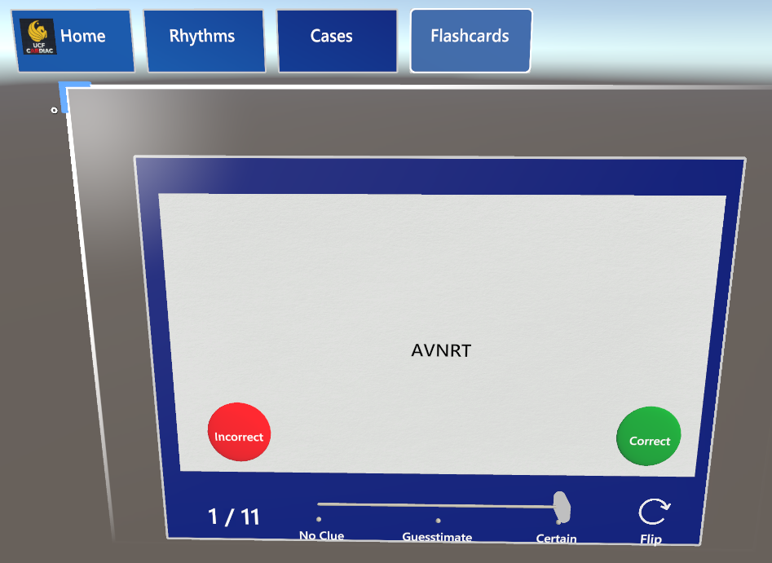

* Once flipped, you may reevaluate your confidence level. You may flip the flashcard back to see the prompt again. Once you are done looking at the flashcard, select whether you got it correct/incorrect. Once you press it, you will automatically move on to the next flashcard. On the bottom left, you’ll see how many flashcards are left.

## Cases

* Press on the case you want to view with your index finger.
* An example of the scene is shown below. On the right of the case box, you’ll also see the heart model that is describing the case

### 